

# Footmarks Management Console Guide

**Patent Notice**: Various use cases and technical information provided herein are protected by a series of provisional and non-provisional patent applications.

Copyright © 2013 Footmarks, Inc. – All Rights Reserved Worldwide – Patent Pending

This document may not be reproduced without the expressed permission of Footmarks, Inc.

Any reproduction, without authorization, is an infringement of Footmarks copyright.

This document contains confidential and proprietary information.

Table of Contents

Footmarks Management Console Guide 1

Overview 3

Create Footmarks Account 4

Create App Key and App Secret in FMC 4

Changing Beacon Content 7

# Overview

This document describes how to use the Footmarks Management Console (FMC). The FMC is used to configure beacon, account and service settings.

# Create Footmarks Account

1. Go to <http://biz.footmarks.com>
2. Click ‘Register new Account’
3. Insert email address
4. Click ‘Request Code’
5. Go to the email address you entered in step 3 and click the verification link
6. A new email will be sent with your temporary password
7. Login to your new account

# Create App Key and App Secret in FMC

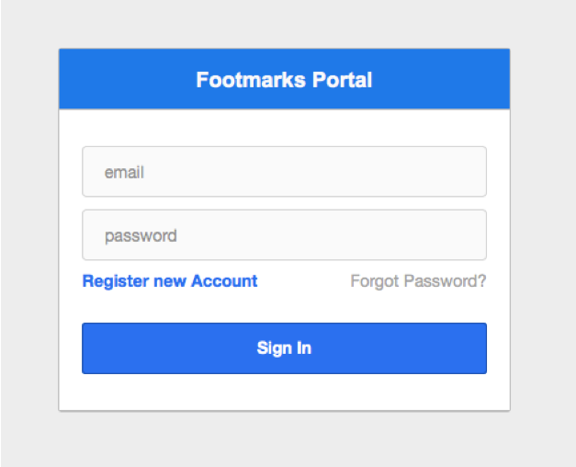

1. Login

2. Click ‘Connect’ button

‘’

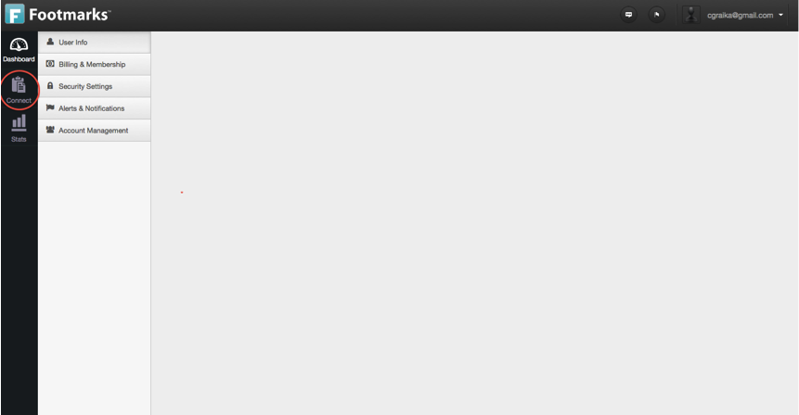

3. Click ‘My Apps’

‘’

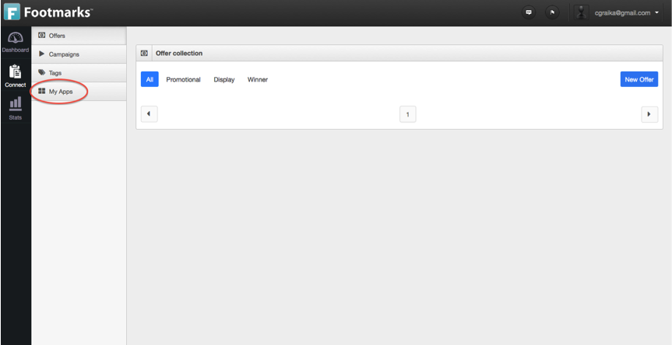

4. Click ‘+’ button

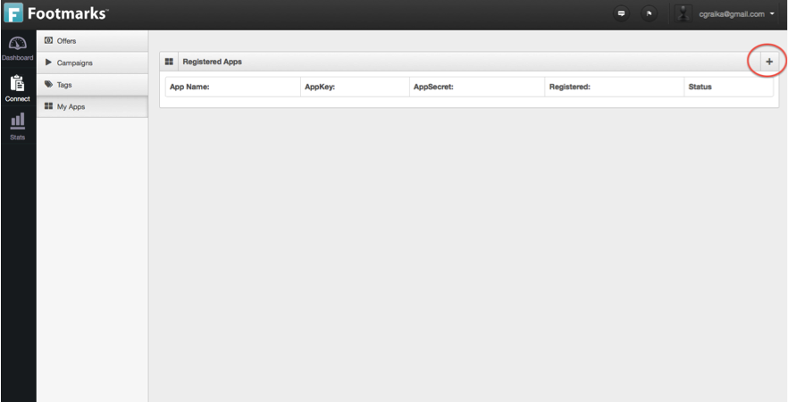

5. Click app name and description. Click ‘Register App’

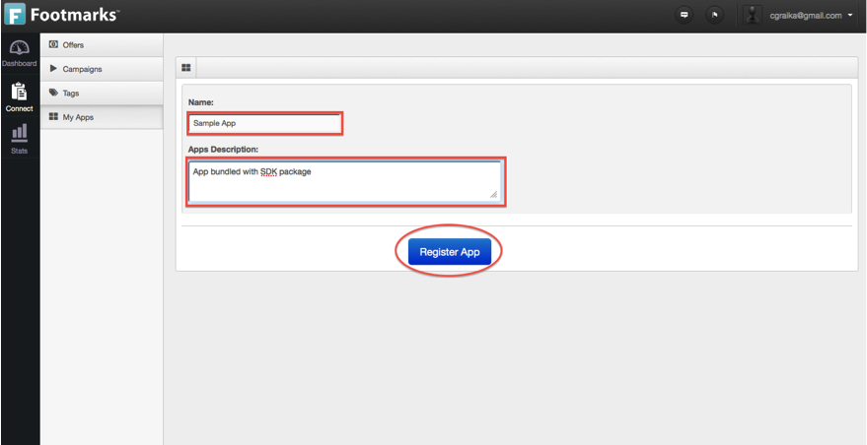

6. Use App Key and Secret pair in loginToFootmarksServer() method

note: see *Footmarks SDK Guide* for info on using values in app

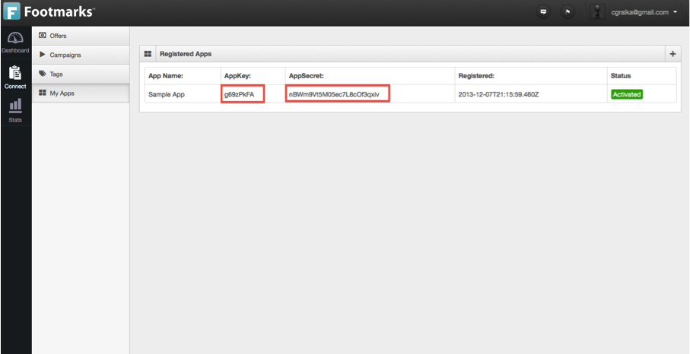

# Changing Beacon Content

1. Click ‘Connect’ button

‘’



2. Click ‘Tags’ button

‘’

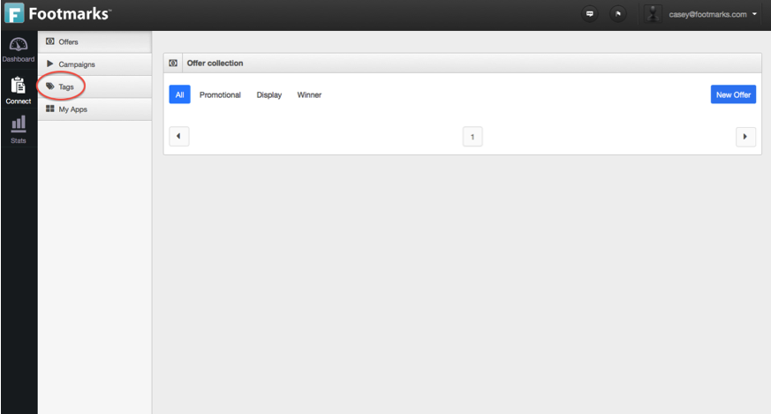

3. Click beacon you would like to modify

‘’

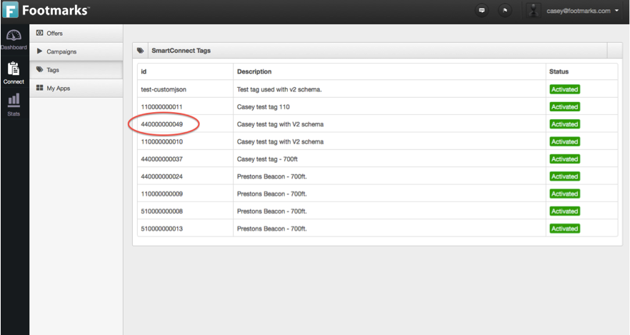

4. Modify JSON response that is returned to app

‘’

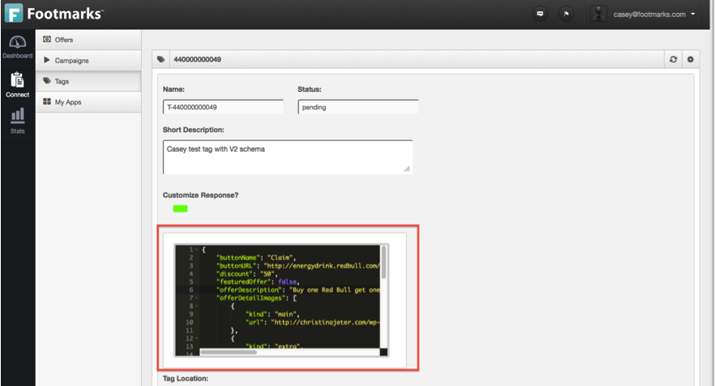

5. Click ‘Save changes’

‘’

